**Exercise 2.b. – Creation of Valid HTML Web Page**

**Name:** Badri MSV **Roll No:** 195002017

**Subject:** UIT1611 – Web Programming Lab **Faculty:** Dr. S. Sasirekha

**Date:** 22.03.2022

**Aim:**

To create a Valid Web Page using HTML.

**Algorithm:**

1. Create any HTML page.
2. Change the HTML page to XHTML – highlight the changes done
3. Check whether the page is a well formatted XHTML document
4. Create a DTD and include the same in the XHTML document
5. Validate the XHTML document using the XHTML validation service (<http://validator.w3.org/>)

**Code:**

<!DOCTYPE HTML PUBLIC "-//W3C//DTD HTML 4.01//EN" "http://www.w3.org/TR/html4/strict.dtd">

<!DOCTYPE html PUBLIC "-//W3C//DTD XHTML 1.0 Strict//EN" "http://www.w3.org/TR/xhtml1/DTD/xhtml1-strict.dtd">

<html lang="en" xmlns="http://www.w3.org/1999/xhtml">

    <head>

        <title>

            Bio Data

        </title>

    </head>

    <body>

        <hr />

        <h1>Badri MSV</h1>

        <p>

            <i>

                Adaptive, Inquisitive and Motivated student. Cybersecurity Enthusiast.

            Willing and open to expanding my knowledge and learning skills beyond the ordinary.

            </i>

        </p>

        <hr />

        <p>

            8124565643 ||

            <a href="mailto:badrimsv@gmail.com">Email</a> ||

            <a href="https://www.linkedin.com/in/badri-m-s-v-62967a61/">LinkedIn</a> ||

            <a href="https://github.com/IIInvokeII">Github</a>

        </p>

        <hr />

        <h2>Education</h2>

        <table border="2"  cellpadding="8">

            <tr>

                <th>Institution</th>

                <th>Degree/Certification</th>

                <th>Year of Study</th>

                <th>Grade</th>

            </tr>

            <tr>

                <td>SSN College of Engineering</td>

                <td>B.Tech. Information Technology</td>

                <td>2019-2023</td>

                <td>CGPA: 8.9 (As of 4th Sem)</td>

            </tr>

            <tr>

                <td>The Schram Academy</td>

                <td>Higher Secondary Certification</td>

                <td>2019</td>

                <td>92.8%</td>

            </tr>

            <tr>

                <td>The Schram Academy</td>

                <td>Senior Secondary Certification</td>

                <td>2017</td>

                <td>94%</td>

            </tr>

        </table>

        <hr />

        <h2>Projects</h2>

        <ul>

            <li>

                <big>Kaggle - Brain Tumor Radiogenomic Classification</big> |

                <small><i>Python</i></small> |

                <a href="https://github.com/IIInvokeII/BrainTumorDetection">>>><img src="github.png" width="18" height="18" alt="NA" /></a>

                <ul>

                    <li>

                        <small>

                            Implemented a Deep Learning CNN Model to predict the status of a genetic biomarker important for brain cancer

    treatment with a team of 5 people

                        </small>

                    </li>

                    <li>

                        <small>

                            Placed 523rd in the leader board from over 1500 teams.

                        </small>

                    </li>

                </ul>

            </li>

            <li>

                <big>Apartment Management Project - AMPlify</big> |

                <small><i>EJS, CSS, Node, Express, MongoDB</i></small> |

                <a href="https://github.com/IIInvokeII/AMPlify">>>><img src="github.png" width="18" height="18" alt="NA" /></a>

                <ul>

                    <li>

                        <small>

                            Implemented a web application geared towards automating the billing process for apartment expenses

                        </small>

                    </li>

                    <li>

                        <small>

                            Completed with a team of 4 members for the Software Design Lab final project

                        </small>

                    </li>

                </ul>

            </li>

            <li>

                <big>Clap Actuated LED Switch</big> |

                <small><i>Arduino</i></small> |

                <a href="https://github.com/IIInvokeII/Clap-LED">>>><img src="github.png" width="18" height="18" alt="NA" /></a>

                <ul>

                    <li>

                        <small>

                            Assembled a working setup of an Clap Actuated LED Switch with minimal cost for Microprocessors Lab

                        </small>

                    </li>

                    <li>

                        <small>

                            Utilized Arduino UNO Microcontroller as the core and understood the immense use of Microprocessors

                        </small>

                    </li>

                </ul>

            </li>

        </ul>

        <hr />

    </body>

</html>

**Output:**

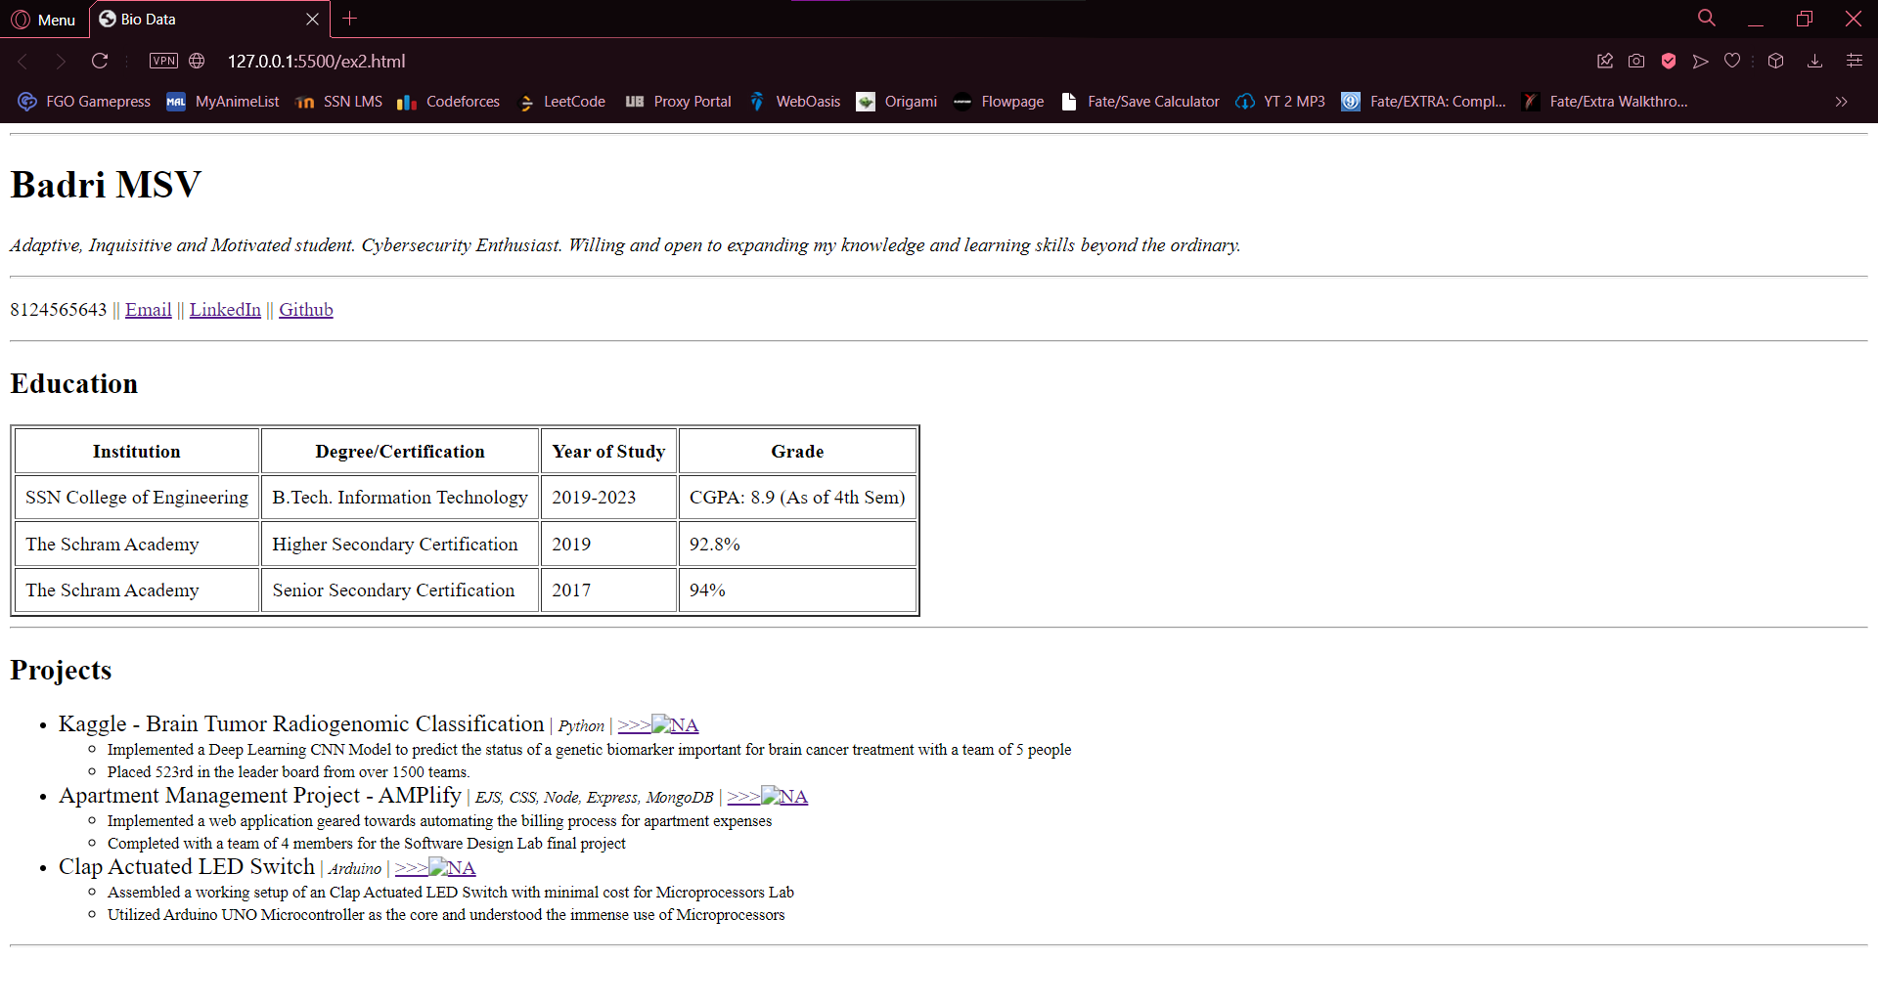

**Result:**

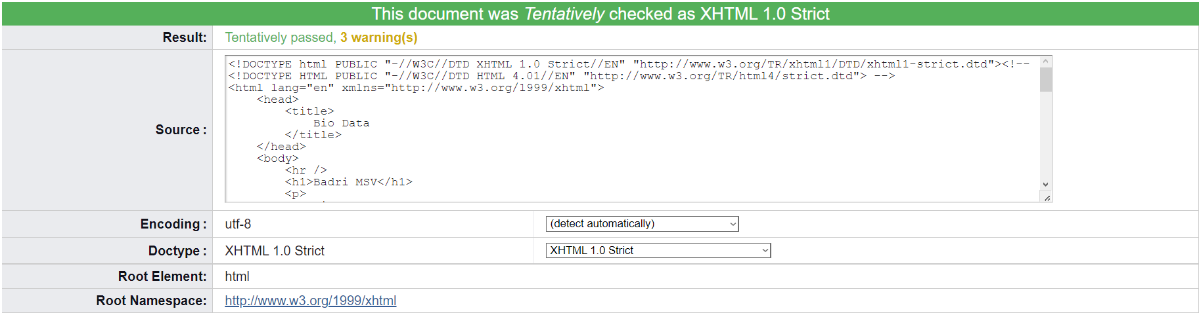

The XHTML was checked and was declared as “Tentatively Passed” by the Validator Website.